Filipino Lawyers of Washington Foundation
2023 Pangarap Scholarship Application
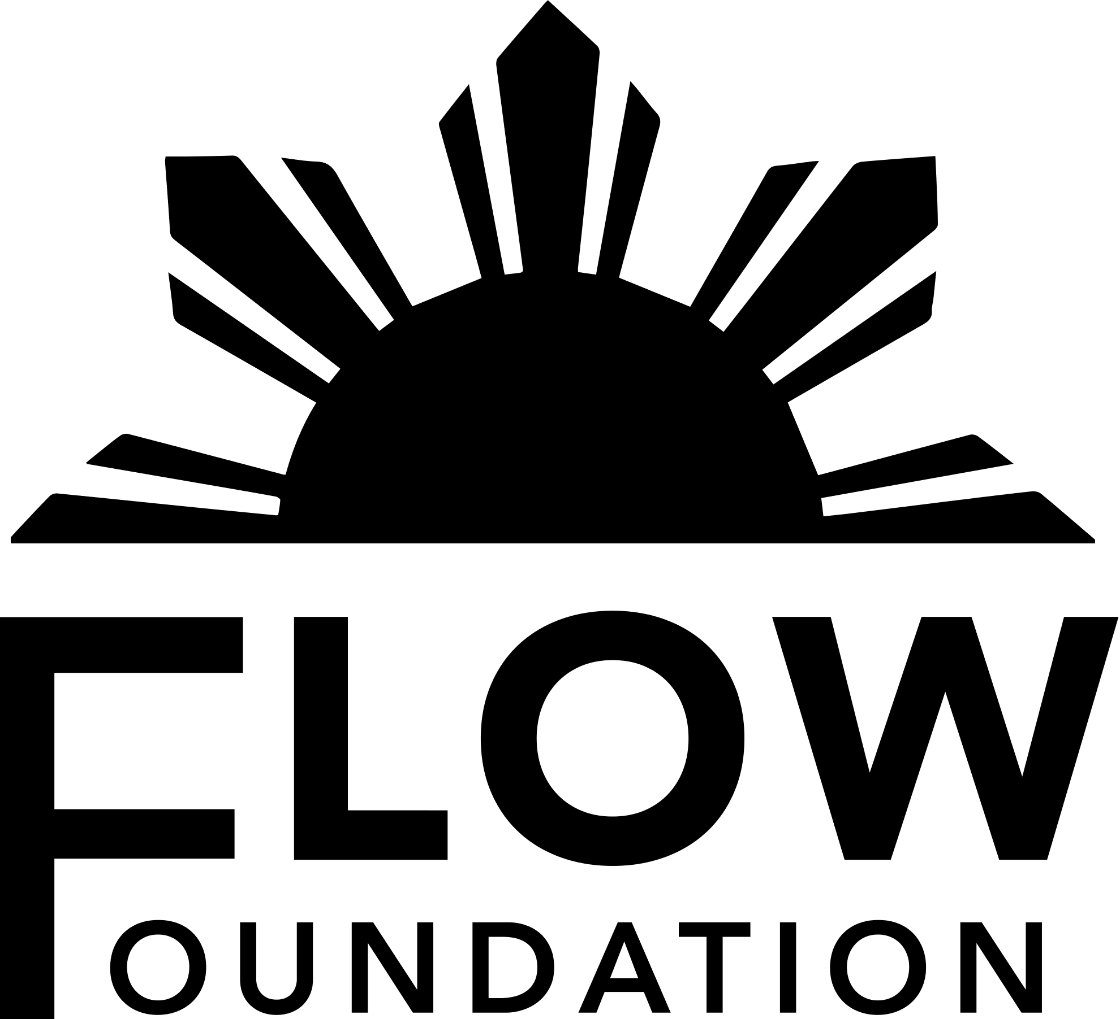
The Filipino Lawyers of Washington Foundation (“FLOWF”), in partnership with the Filipino Lawyers of Washington (“FLOW”) awards scholarships annually to law students in the Pacific Northwest of up to $10,000 total collectively. The scholarships are intended to recognize law students who have a demonstrated significant commitment to community service, particularly service to the Filipino/Filipino American community. You need not be of Filipino ethnicity to apply. To learn more about FLOW, please visit our website at www.filipinolawyers.org.
JUDGING CRITERIA
All applicants will be judged on the following criteria:
- Community service and community involvement, particularly service to the Filipino/Filipino American community;
- Academic achievement, work experience, activities, and post-law school goals; and
- Essay.
There is no minimum G.P.A. requirement
SELECTION PROCESS & DEADLINES
The scholarship recipient will be selected and notified by the FLOWF Scholarship Committee.
The award will be presented at the FLOW Annual Barrio Fiesta (Dinner) on Saturday, October 28, 2023.
Timeline
Friday, October 13, 2023 | Applications are DUE by 8 PM PST
Mon.-Fri, October 15-20 | Finalists contacted for telephone/video interviews
Monday, October 23 Saturday, October 28 | Scholarship recipients will be contacted by 6pm PST Presentation at the FLOW Annual Barrio Fiesta (Seattle Filipino Community Center)
***Submissions must be sent by e-mail to FLOWF Scholarship Committee Chair Elaine Pascua at epascua@savers.com.

2023 PANGARAP SCHOLARSHIP APPLICATION

*Please include a headshot and short (250 word limit) bio with your application.

Name __________________________
Address ________________________ City _________ State ________ Zip Code _________
Telephone ____________________ Email ____________________________
Undergraduate School _________________________ Degree/s ______________________
Law School ______________________________
Other Schools & Degrees ________________________________________________________

I. Academics – List GPA and honors/awards in undergraduate and graduate programs:
Undergraduate GPA ______________

II. Community Involvement and Activities – List volunteer or community activities, and other activities including school, sports, clubs, committees, church, etc. Discuss leadership roles, hours per week, and extent of involvement.

III. Post Law School – Briefly state your career interests and the goals you would like to pursue after law school.

IV. Please provide the names and phone numbers of two references and describe the capacity they know you.

V. In 250 words or less, describe how you would use your law degree to affect change to the community in a positive way. What specific changes would you make and why? (*You may attach additional page if necessary).

VI. In 250 words or less, explain a situation in which your leadership or a community service experience made a difference. What was accomplished? (*You may attach additional page if necessary).

VII. Please attach a resume or other biographical information that summarizes your educational and employment background.

Must be currently enrolled in an accredited law school as a part- or full-time student. Other post-graduate or professional school students not also enrolled as an active law school student will not be considered.

